  SNIR 2 SNIR2 | LAN PARTY |     ESLA

Your mission:

You are entrusted with the organization of a LAN party in a sports hall. 300 guests will be present.
The place needs to be equipped with an ADSL box, 188 desktops (connected with RJ45 plugs), and 100 Wi-Fi connected laptops.
Budget : 20 000€

- TASK 1 : Observe the diagram of an ADSL box and fill in the caption.
- TASK 2 : Look at the map of the sports hall and choose the CISCO equipment you will need on https://www.amazon.com
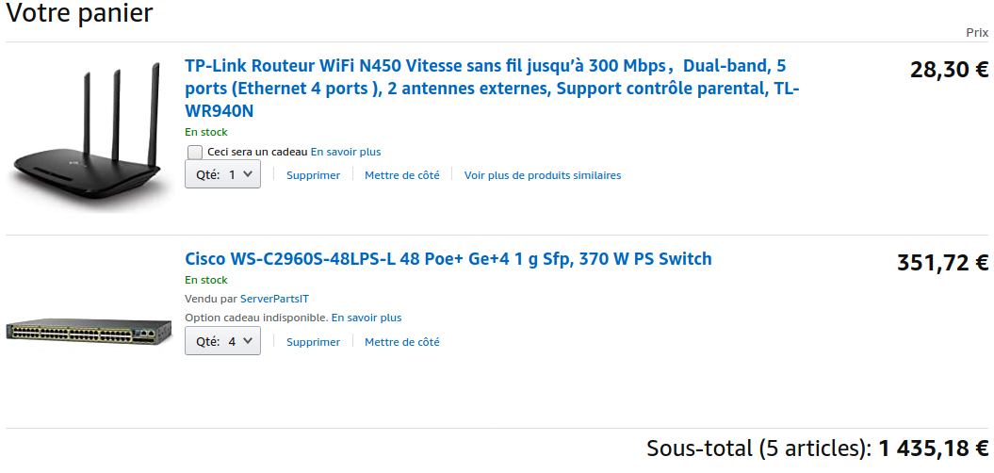

- FINAL TASK : Project the map of the sports hall on the white board and use it to explain the solution you have envisaged.
EXTRA HELP:
You may find some help from the following video:
https://www.youtube.com/watch?v=8J00rfZE17Y
The speech delivery being quick, you are exceptionally allowed to use subtitles.
2 schémas : - implémentation de la salle (switch, router, wifi, alimentation électrique, PC)
- schéma logique Packet Tracer
coût du matériel (réseau, électrique) → longueur de câble
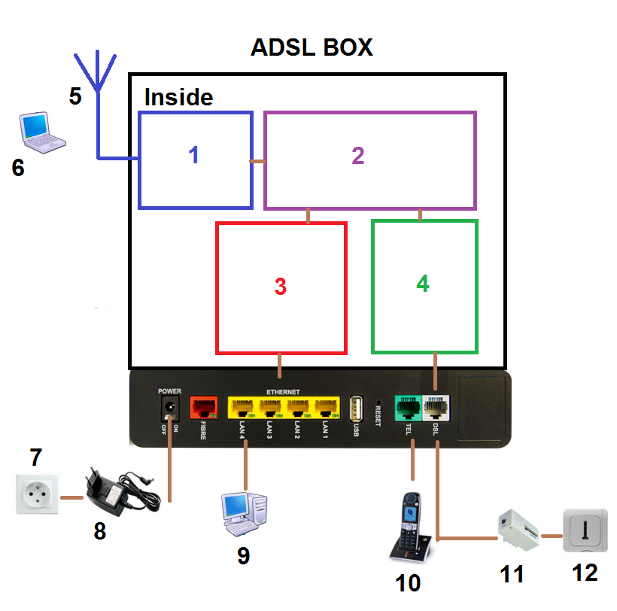
1 → WIFI access point
2 → router
3 → switch 4 ports
4 → Modem
5 → WIFI signal
6 → laptop (wireless)
7 → wall socket
8 → power cable (power supply)
9 → computer (Ethernet)
10 → home phone
11 → ADSL filter
12 → phone plug
